Regents Earth Science

Interpreting Earth’s History
Notes
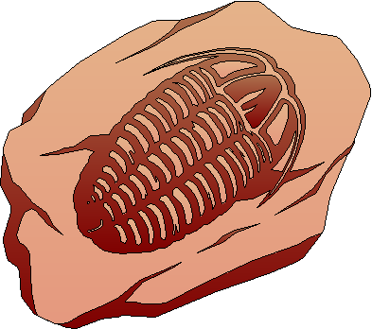

Name:___________________________________________________________________

Unit Overview

Part 1 – The Geologist as a Detective
A. Geologic Sequencing
B. Fossils
C. Rock Correlations

Part 2 – Geologic Time Scale
A. Early Life

Part 3 – Radioactive Dating

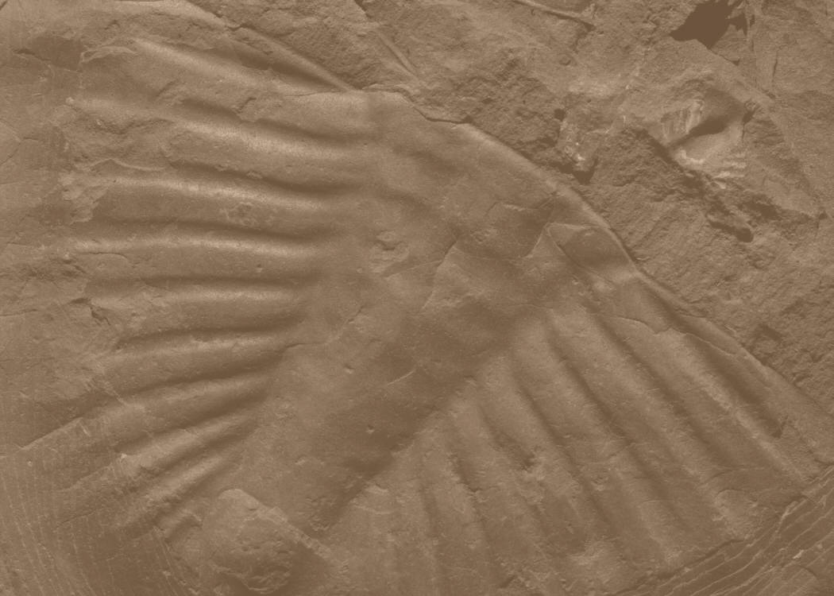

Interpreting Earth’s History

Part 1 - The Geologist as a Detective
- Planet Earth probably formed about 4.5 billion years ago from an accumulation of rock, dust, and gases drawn together by its own gravity.
  - The rocks of Earth’s crust provides clues about its past.

A. Geologic Sequencing
- Geologists locate, observe, and interpret the evidence and clues recorded in Earths rocks.
  - The primary role of the geologist is to use the evidence found in rocks and reconstruct a sequence of geological events.
  - Several principles that guide them…

- Uniformitarianism
- The idea that the processes that shape Earth’s surface today, (volcanoes, earthquakes, deposition, and erosion) are the same processes that occurred in the geologic past.
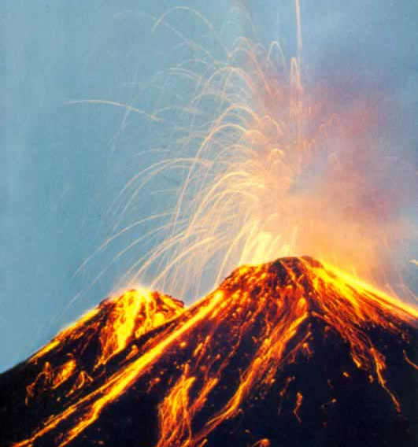
  - “the present is the key to the past”

- Superposition
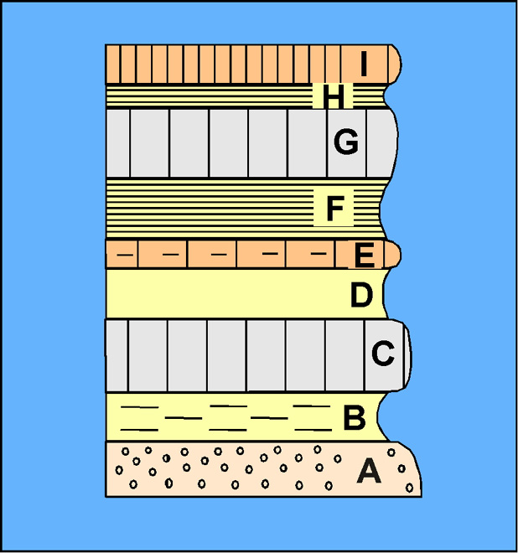
- The law of superposition states that the rocks at the bottom of an undisturbed exposure are usually the oldest.
  - Lower layers are in place before newer ones can be deposited on top of them

- Original Horizontality
5. Sediments are deposited horizontally (thanks to gravity…..). When rock layers are found to be tilted, it is assumed that they were tilted by some geologic process AFTER they were deposited.
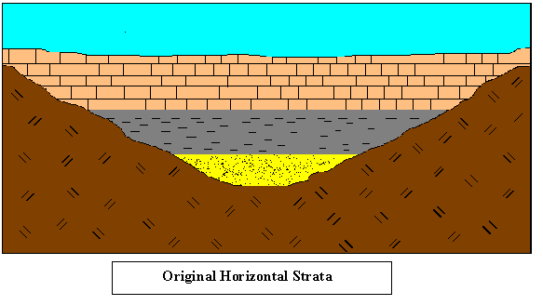
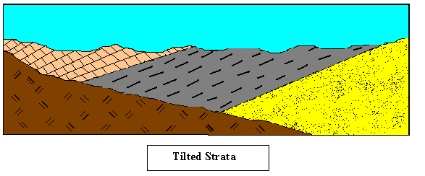

- Igneous Intrusions, Extrusions, and Inclusions
6. A unit of rock is always older than the geological processes that change it.
  - Igneous formations can provide clues about the sedimentary layers around them

7. An extrusion occurs when molten rock flows onto Earth’s surface.
  - Younger than the rock below it
  - create a ‘zone of contact metamorphism’
  - Sediments may be deposited after

8. An intrusion occurs when magma squeezes into or between layers of pre-existing rock.
  - Changes the surrounding rock directly above, below and next to it (contact metamorphism)
  - Can surround older rock fragments – inclusion

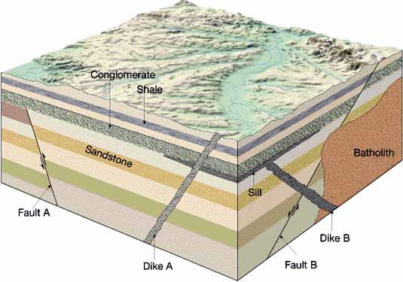

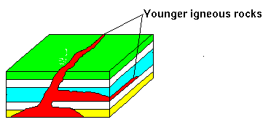
- Crosscutting Relationships

9. Intrusions of magma are always younger than the rocks they invade.

- Folds and Faults
10. Tectonic processes within our planet can twist rock layers after they have formed.
  - Folds – bends in rock layers
  - Faults – are breaks in the rock b/c of movement

11. Folding or faulting can lead to:
  - Offset layers
  - Exceptions to the law of superposition

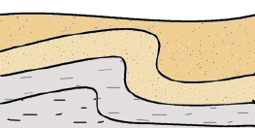
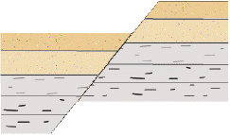

Establishing a Geological Sequence
12. No single location shows a complete record of the geologic past.
  - Erosion – causes gaps in the rock record

13. When new rock layers are deposited onto an eroded surface – we call it an unconformity.

14. An unconformity in a rock outcrops shows:
  - The area was above sea level (uplifting) for some time and erosion took place
  - Later, the area was below sea level (sinking) and deposition took place

F – intrusion (put in fuzzy line)

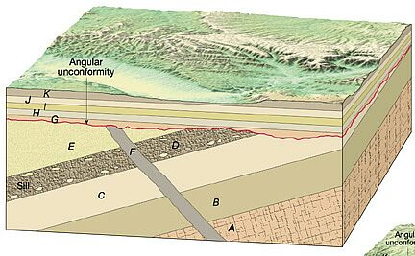

B. Fossils
1. Fossils are the preserved remains or traces of living organisms.
  - Provide clues to the past
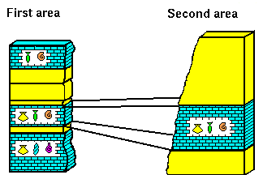
  - Tell about life forms and environments
  - Help determine the relative age of the rock layers

2. The process of metamorphism (heat or pressure) destroys fossils.
- Found in sedimentary rocks

3. There are different types of fossils:
1. Body fossils: part of the original organisms (teeth, bones, shell)
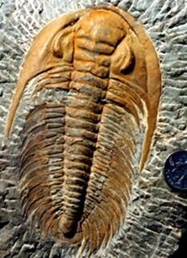
2. Whole animals - the entire organisms is preserved
3. Trace fossils – the imprint, impression, footprint, and coprolites (animal droppings)

4. Fossils can form in different ways:
    - In sediment that hardens into sedimentary rock (* most common!)
    - Refrigeration – preserved in large masses of snow and ice
    - Amber – insects preserved in the resin of pine trees
    - Petrifaction – gradual changing of organic matter into a stony substance (just like in Pompeii bones and trees)
    - Tar Pits – animals are trapped in large deposits of asphalt

5. New York State has fossils of coral and warm water marine organisms, indicating that the area once was a tropical sea.
- More recent fossils of mammoths, mastodons, from the last ice age

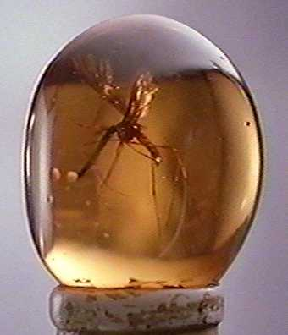
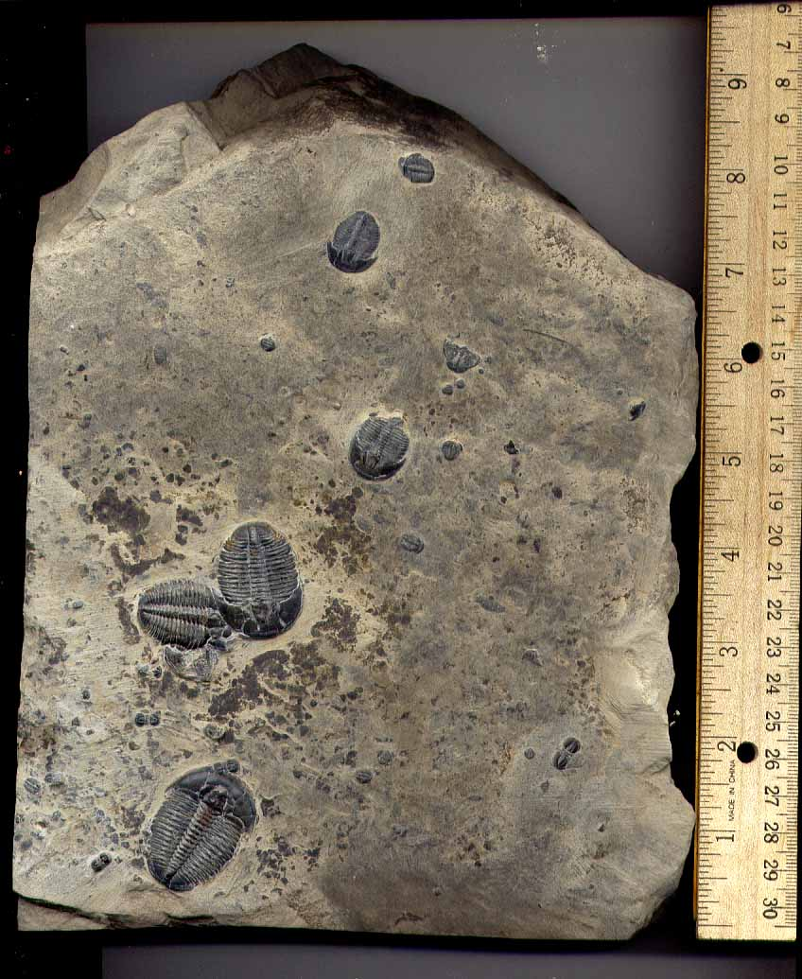
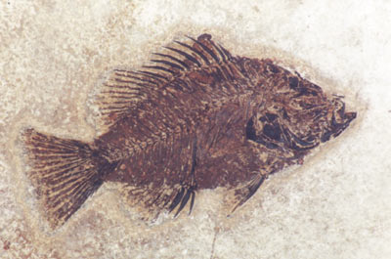

C. Rock Correlation
1. Geologists try to match similar rock strata in different locations to see if they formed at the same time or under similar conditions.
- Correlation

2. There are several ways to correlate rock strata:
i. match rock strata in one location to another
ii. compare index fossils
- Fossils that existed for a brief time, but over a large geographical area
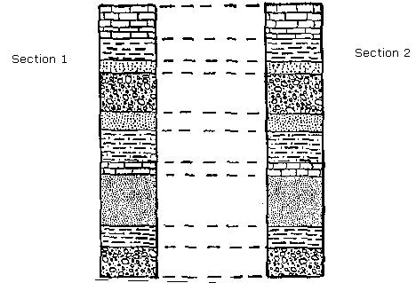
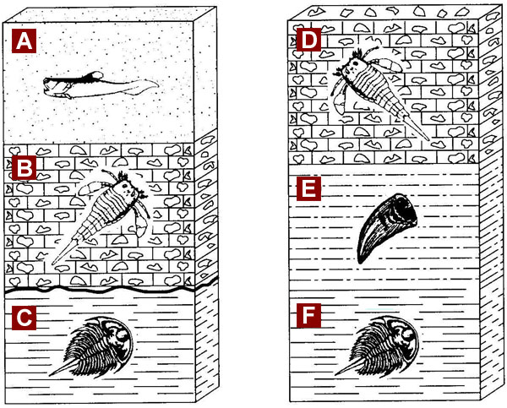

Part 2 - Geologic Time Scale

1. The geologic time scale is a sequence of events that took place on Earth based on fossils.
- Sequence of fossil groups oldest to youngest

2. The geologic timetable or ‘calendar’ is based on 3 sources of evidence:
1. A study of the relative ages of the rock layers
- Relative time – indicates whether an object is older or younger that something else.
2. An analysis of the fossil record
3. Radioactive dating.

3. Groups of fossils are named for the locations where they were first found.
Devonian – Devonshire, England
Cambrian - Cambria, Wales
Permian – Perm Mts, Russia

4. The geologic scale is divided into several parts:
- Each division is shorter and the changes of life forms is not as large

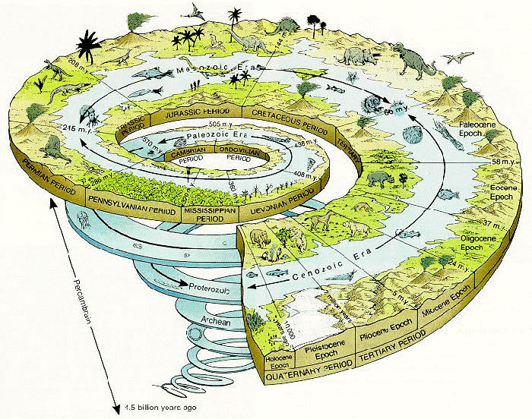

- Eons – The largest category
Precambrian – before advanced life
Phanerozoic – after animals with shells

- Eras – subdivisions of Eons
Paleozoic: “ancient life”
Mesozoic: “middle life”
Cenozoic: “recent life”

- Periods – smaller divisions of Eras
Are named after the locations in which fossils were first found.
Ex. Devonian – Devonshire, England

- Epochs – even smaller groups of periods, usually expressed in late, middle, early

5. The Geologic Time scale in your ESRT not only breaks down these major sections of geologic time, but also indicates:
- the type of life during each period
- the distribution of fossils on earth
- the position of land masses on earth
- the geologic history of New York State
- orogeny – mountain building processes

6. Geologists use the geologic time scale to study the local bedrock of NY and to construct geologic maps. (ESRT Page 3)

A. Early Life
1. By using fossils found, geologists have inferred that life began with the earliest forms of fossils about 540 mya. – Cambrian period.

2. As geologists studied fossils they noticed:
- that fossils became more complex
- that some organisms disappeared suddenly
- that a variety of sizes, shapes, characteristics existed in all species.

3. Geologists are still trying to fit all the peaces of the puzzle together to complete the geologic/fossil record of Earth.

4. The study of the fossil record shows several points in geologic time in which a large number of species became extinct – mass extinctions.
    - Linked to impacts of meteoroid or asteroid impacts, global climate changes, interrupted food chains
    - Dinosaurs, trilobites, eurypterids
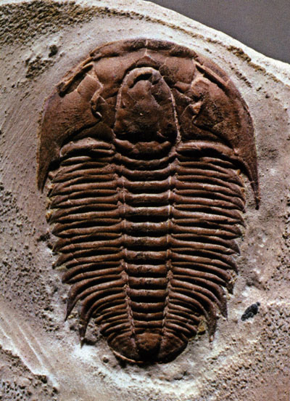
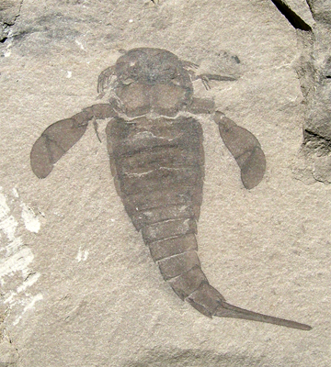
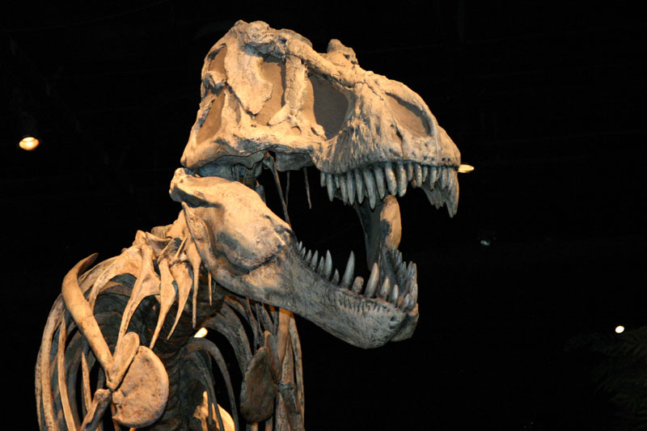

Part 3 - Radioactive Dating
1. The geologic time scale became an absolute time scale when numbers and units of time were added.
    - Margin of error exists

2. Chemical elements have several forms called isotopes.
- Differ in the number of neutrons in their atomic nuclei
- Ex. Carbon-12 (6 protons, 6 neutrons), Carbon-14 (6 protons, 8 neutrons)

3. If the nucleus of an isotope has more or less than the number of neutrons in its stable form it may be radioactive.
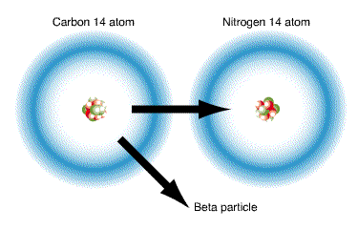
- Will break down into a different element called radioactive decay product
Ex. Carbon-14 → Nitrogen-14
Potassium-40 → Argon-40
Uranium-238 → Lead-206
- Decay at predictable rates

4. The decay of a radioactive element is measured by its half-life.
- The time required for half the atoms in a sample of a radioactive element to change to the decay product

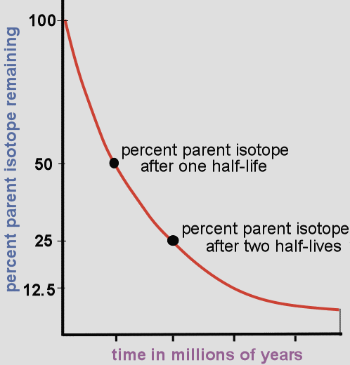
5. If scientists know how much of the decay product there is they can determine how many half-lives it has gone through

6. Each radioactive element has its own half-life.
- Since carbon-14 has a half-life of only 5,700 years it can only be used to date samples no older than 50,000 yrs
- Uranium-238 can only be used to date the oldest rocks

Radioactive Decay Data (page 1 ESRT)
Radioactive Isotope | Disintegration | Half-Life (years)
Carbon-14 | C¹⁴ → N¹⁴ | 5.7 x 10³
Potassium-40 | K⁴⁰→ Ar⁴⁰ (or Ca⁴⁰) | 1.3 x 10⁹
Uranium-238 | U²³⁸ → Pb²⁰⁶ | 4.5 x 10⁹
Rubidium-87 | Rb⁸⁷ → Sr⁸⁷ | 4.9 x 10¹⁰

