Regents Earth Science

Meteorology
(I and II)
Notes

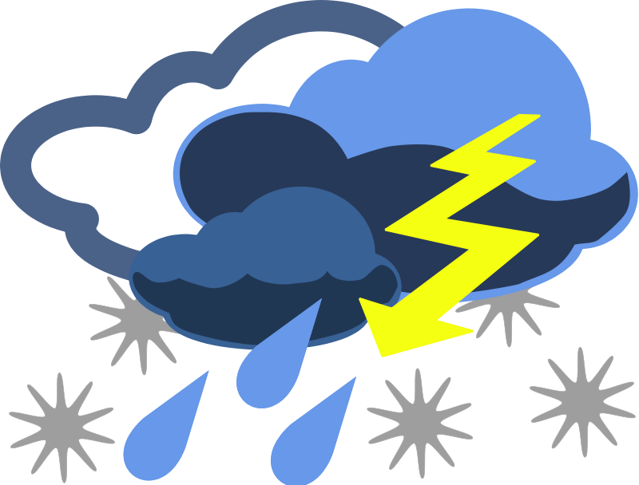

Name:_________________________________________________________________

Unit Overview
Meteorology I
Part 1 – Properties of the Atmosphere
A. Origin of the Atmosphere
B. Composition of the Atmosphere
C. Structure of the Atmosphere

Part 2 – What is Weather?
- Factors of Weather
- Station Models
- Temperature, Pressure, Wind

Part 3 – Moisture
A. Humidity and Dew Point
B. Cloud Formation
C. Precipitation
D. Phase Change

Meteorology II
Part 4 – Weather Systems
A. Synoptic Weather Maps
B. Air masses
C. Fronts
D. Pressure Systems

Part 5 – Storms
- Watches & Warnings
- Thunderstorms
B. Tornadoes
C. Hurricanes
D. Winter Storms

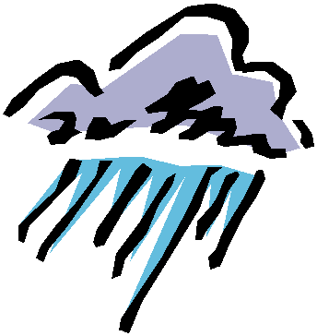
Part 1 - Properties of the Atmosphere

- Origin of Earth’s Atmosphere
1. Earth’s early atmosphere was probably very different from the atmosphere today
- Dominantly Carbon Dioxide (CO₂) and Nitrogen (N)
- Formed by out gassing of volcanoes and photosynthesis

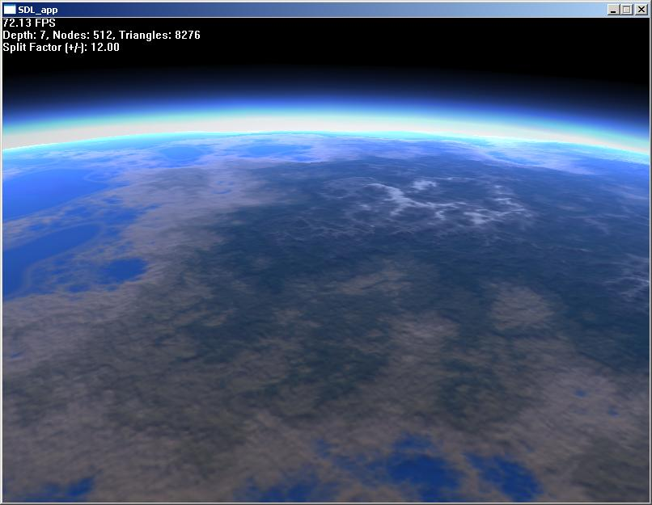
- Composition of the Atmosphere
2. Atmosphere
- the gaseous envelope that surrounds the Earth
- is found all around us
- extends up ~300km (180mi)

3. The atmosphere is composed of a mixture of gases that we call ….. air.
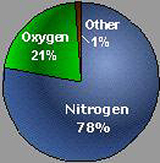
78% Nitrogen
21% Oxygen PAGE 1 ESRT
.9% Argon
.03% CO2
.07% Others (water vapor, methane, helium, neon, hydrogen)

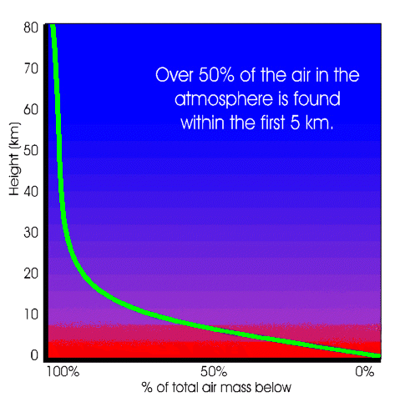
4. Earth’s air thins out very quickly.
- As a result, 50% is found within the first 5 km (3.2mi) and 99% of our atmosphere is found within the first 32km (19 miles) above Earth’s Surface

- Structure of the Atmosphere
Pg 14 esrt
5. Scientists have divided our Atmosphere in four layers based on Temperature changes.
1) Troposphere
2) Stratosphere
3) Mesosphere
4) Thermosphere

6. Each layer is separated by a boundary (interface) of constant temperature – known as a “pause”
- Tropopause, stratopause, mesopause

7. The troposphere:
- The lowest layer, starts at the Earth’s surface
- Contains the gasses necessary to life on Earth
- 99% of all weather occurs in this layer
- Temperature decreases in altitude
- The troposphere ends at the Tropopause, where temperature remains constant
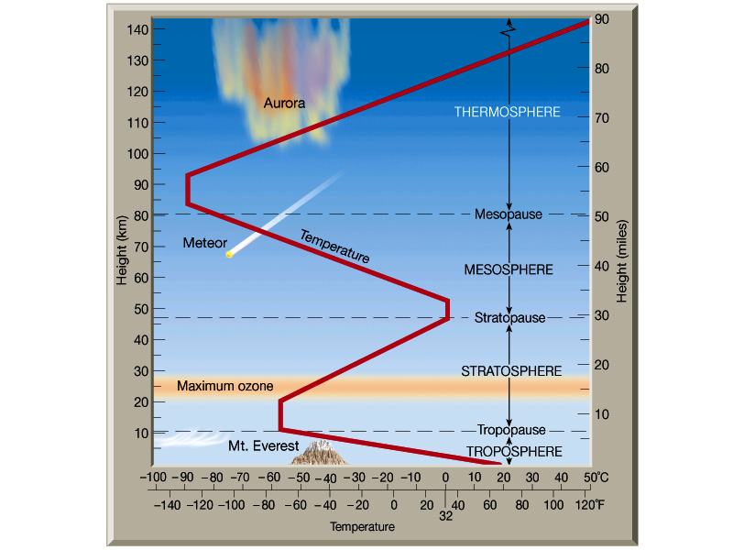

8. The Stratosphere:
- Temperature changes increases with height
- Has strong, steady winds, and no weather
- Jets aircraft fly in this level
- Contains the Ozone Layer!! Blocks UV rays from the Sun….
- The stratosphere ends with the Stratopause, where temperatures remain constant

9. The Mesosphere:
- The 3rd layer where Temperatures decrease
- The layer ends with Mesopause, where temperatures become constant

10. The Thermosphere:
- The last layer where Temperature increases due to absorption of solar energy
- Contains the ionosphere
          - Air is highly ionized (sun’s UV rays knocks electrons off the oxygen atoms)
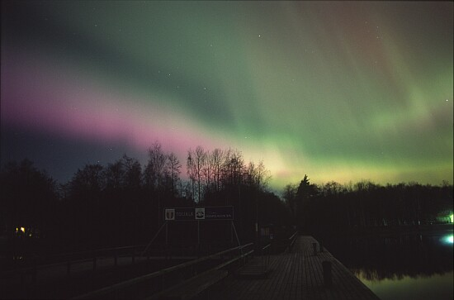
          - Causes reflection of radio waves and the auroras

Part 2 - What is Weather?
1. Weather - is the state of the atmosphere at a given time in terms of temperature, sky cover, precipitations, wind, ect..
- Climate - the long term average of weather conditions for a location.

2. How is Weather Studied and Recorded?
- is studied and predicted by scientists called meteorologists.
-is recorded on station models and maps

3. What is Meteorology?
- a science that deals with the atmosphere and its phenomena, especially with weather and forecasting.

- Factors of Weather

4. Meteorologists take measurements and create models and maps of the major factors of weather: Temperature, Moisture, Pressure, and Wind

- Station Models
5. Station models are a standardized form of recording a variety of weather data that can be used to interpret information on a synoptic weather map.
- Each measurement is placed at a preset location
- Barometric pressure is coded (1012.3 = 123)
- Wind arrows indicate the direction wind is coming from!
- Page 13 ESRT
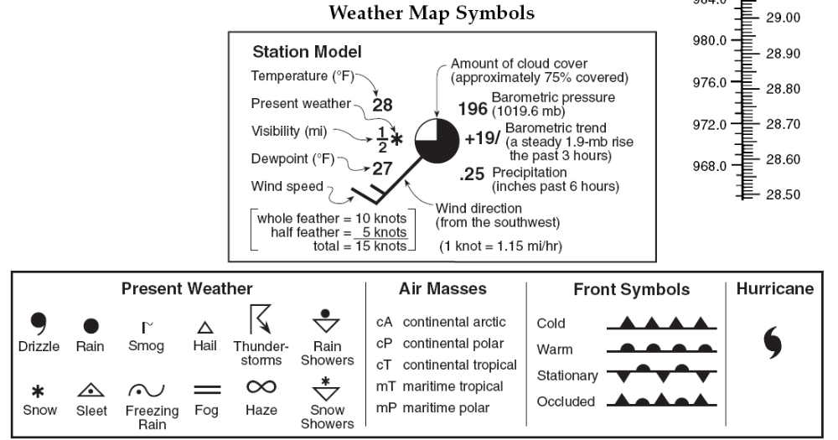

- Temperature, Pressure, Wind
6. The Sun is a major source of energy for Earth.
- Electromagnetic energy over the wide range of wavelengths that make up the electromagnetic spectrum

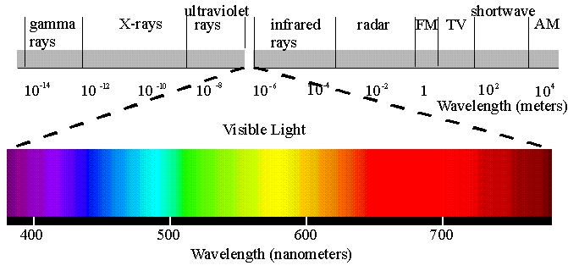

7. Earth’s atmosphere filters out some of the short-wave radiation.
- Most of what reaches Earth’s surface is in the narrow band that we recognize as visible light
- Of all the solar radiation that actually reaches Earth, about 75% is used to evaporate water

8. Earth also radiates electromagnetic energy, mostly in the infrared (heat) part of the electromagnetic spectrum.
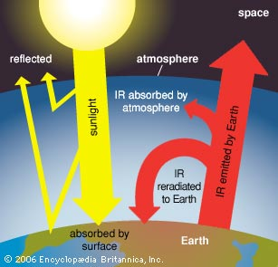

9. At Earth’s surface changes in Temperature tend to be cyclic:
- Daily cycle
- Seasonal Cycle

10. Short term factors such as cloud cover and regional weather systems affect temperature
- Clouds reduce daytime temperatures by reflecting the sun’s rays back into space
- At night clouds hold heat energy back to Earth

11. Temperature
- is a measure of the degree of hotness or coldness ex. 100°F 32°C

- is a direct result of the amount of heat
energy received from the Sun
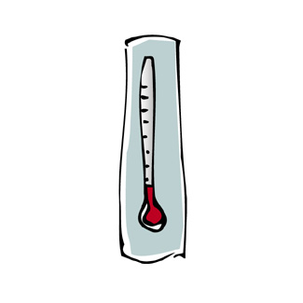
- is measured using thermometers
        - Fahrenheit, Celsius, Kelvin
          - Page 13 ESRT

- is depicted on weather maps with Isotherms
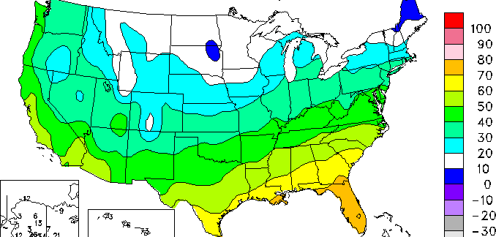
“Lines of equal temperature”

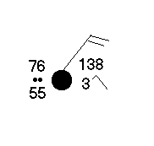
- Is shown on a station model: Top Left

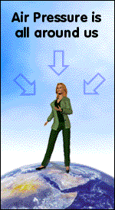

12. Air pressure is caused by the weight of the atmosphere.
- 14.7 lbs/in² or 1013.2 millibars

13. Air pressure is greatest at Earth’s surface and decreases with altitude.

14. Changes daily based on the temperature and amount of moisture in the air
- As temperature and moisture increases, pressure decreases.

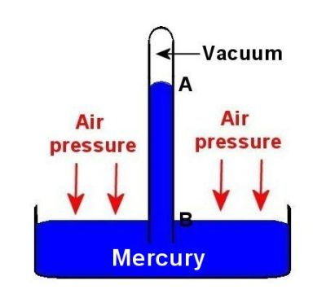
15. Is measured with a barometer
- Aneroid or mercury
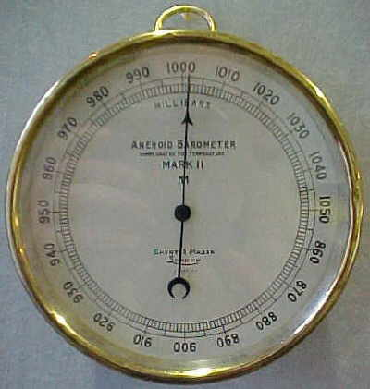

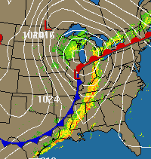

16. Is depicted on a weather map with isobars
        - Recorded every 4 millibars apart

17. Is shown on a station model: upper right

18. Factors That Affect Atmospheric Pressure:
- Altitude
– air becomes less dense with increasing altitude
- air expands as it rises, lowering in pressure
- Temperature
– as air cools it will contract and become more dense, increasing in pressure
- as air warms it will expand and become less dense, decreasing in pressure
- Humidity (water as gas)
- when water evaporates into the atmosphere, the air expands to take in the ‘extra’ molecules
- Humid air is lighter than dry air
- as humidity increase the pressure decreases

19. Wind - is the result of uneven heating of the earth and the atmosphere which causes a difference in pressure.
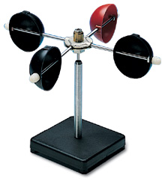
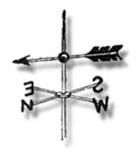
  - Wind always moves from high to low pressure!!!
  - Direction is measured with a wind vane
  - Speed is measured with an anemometer
  - Winds are named for the direction in which they come from! (b/c they bring weather with them)

20. Wind is depicted on a weather map with arrows with lines or triangles on its staff and is shown on a station model:
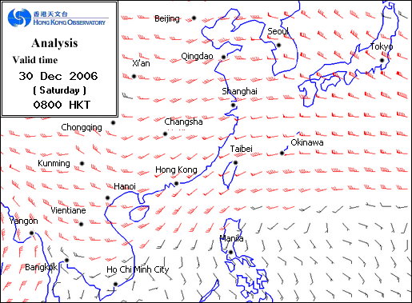
Center Picture

21. Winds are controlled by two forces:
a. Pressure Gradient force – the difference in pressure between two locations.
- if isobars are far apart, the pressure differences are small and winds will be weak
- if the isobars are close together, the pressure differences will be great, and the winds stronger
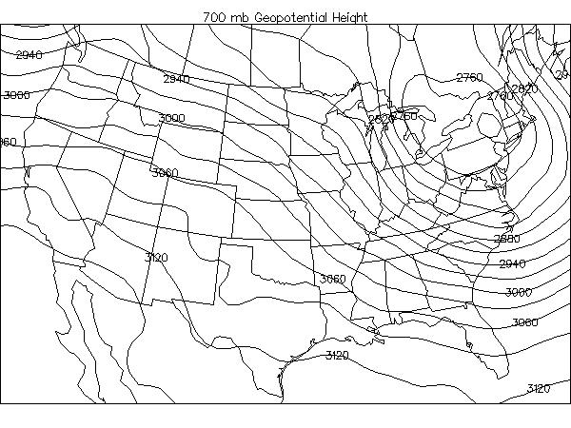
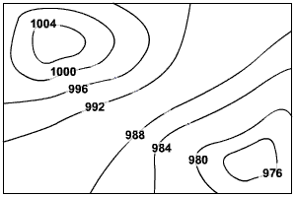

b. The Coriolis Effect – caused by the spinning motion of Earth
- causes paths of winds to curve to the right in the Northern Hemisphere and the left in the Southern Hemisphere
- only effects large scale winds
“Because Earth is spinning underneath the moving air”
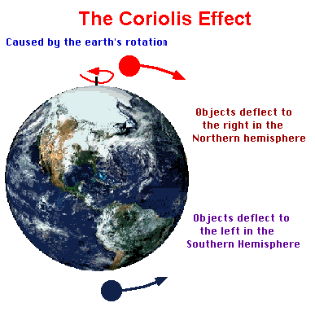

22. There are two types of winds:
- Local winds - winds that blow over a location of 100 km or less
- Global winds – winds that blow on a planetary scale

23. Types of local winds:
- Land Breezes and Sea Breezes
- Mountain and Valley winds
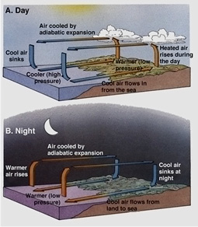
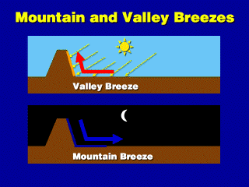

24. Types of Global Winds:
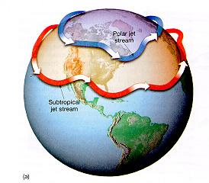
a. Jet Streams – currents of very fast winds that flow in the upper atmosphere
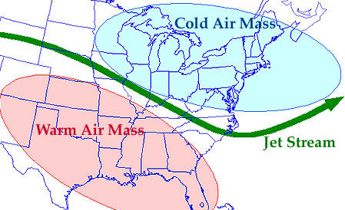
- they flow west to east, and separate cold air masses from warmer air
- control weather patterns in the mid-latitudes

b. Prevailing Winds – large scale winds that dominantly blow in a continuous direction
-are the cause of the ocean current patterns
- pattern is determined by the Coriolis effect
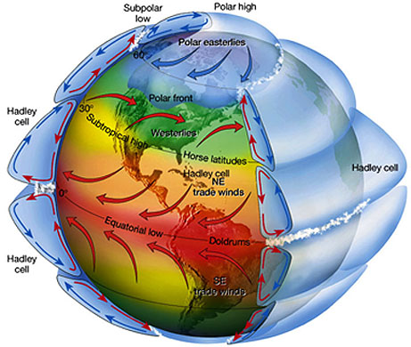
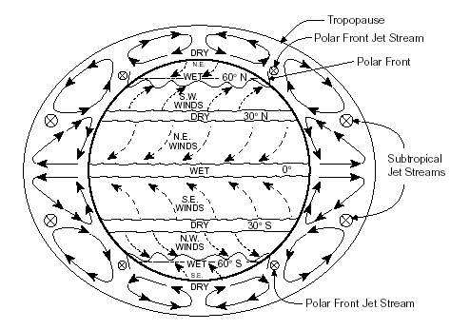

Part 3 - Moisture
A. Humidity and Dew Point
1. Atmospheric moisture is the amount of water present in the atmosphere, whether it be solid (ice), liquid (water) or gas (water vapor)
  - Often referred to as humidity
  - explains how/why clouds form, and the amount of precipitation we get

2. When the air contains as much moisture as it can, we say the air is saturated.

3. The air’s ability to hold water vapor depends on the temperature.
- Warmer air can hold more water vapor than cold air
- Every 10°C increase in temperature will double the capacity
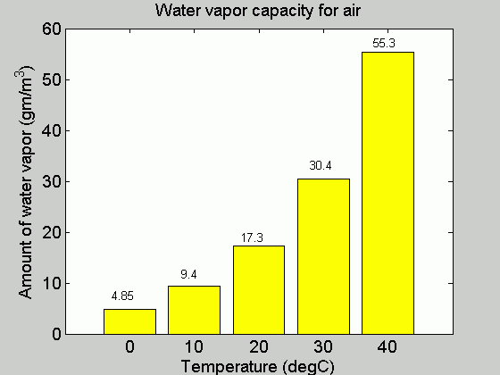

4. If the temperature of the moist air is lowered enough, the air will become saturated.
  - The dew point is defined as the temperature to which air must be cooled to become saturated.

draw

5. Dew Point is recorded in a station model: bottom left

6. Meteorologist use several methods to determine the moisture content of the atmosphere.
  - They use a psychrometer and a dew point temperature table

7. The psychrometer is made of two thermometers mounted so they can be swung through the air.
  - One thermometer records the air temperature – dry bulb
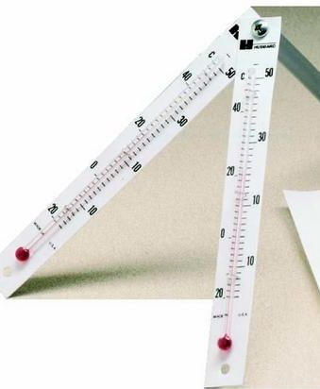
  - One thermometer has a water soaked cloth over the bulb (wet bulb) and records the temperature caused by evaporation
  - Used to measure both dew point and humidity!!

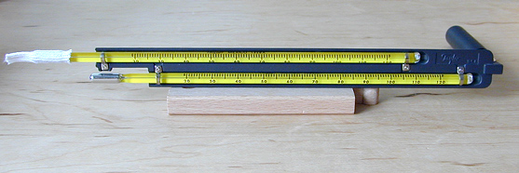

8. Evaporation is a cooling process!! Evaporation causes the wet bulb to record lower temperatures.
- The dryer the air the more evaporation will take place – the greater difference between wet and dry bulb temperatures
- The wetter the air the less evaporation will take place – the less difference between wet and dry-bulb temperatures

9. Once wet-bulb and dry-bulb temperatures are determined, meteorologist can calculate the relative humidity.
- The ratio of the amount of water vapor in the air compared to the air’s temperature

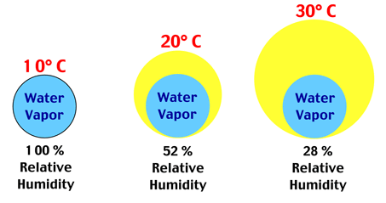

Page 12 ESRT
Relative Humidity (%)
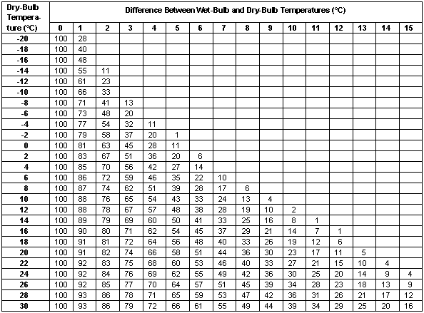

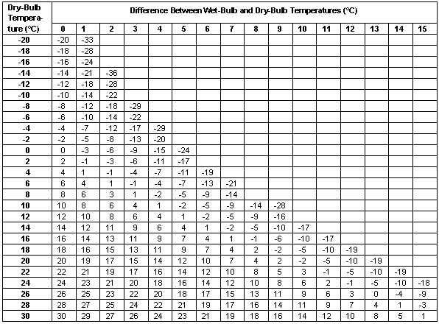
Dew Point Temperatures

Quick Practice:
#1. Joey used a psychrometer to calculate the relative humidity of the classroom. He recorded the dry-bulb temperatures to be 22°C and the wet-bulb to be 16°C.
What was the % humidity? ______________
What is the Dew Point of the room?______________

Humidity –
- Find the difference between the wt bulb and the dry bulb….. (22-16 = 6)
- Go to the humidity chart. Find 22° on the left side column; find 6° difference on the top row.
- Read down and across. Match them up.…..53%

Dew Point –
- Find the difference between the wt bulb and the dry bulb….. (22-16 = 6)
- Go to the dew point chart. Find 22° on the left side column; find 10° difference on the top row.
- Read down and across. Match them up. …. 12°

- Formation of Clouds
10. A cloud is a large object made of billions of tiny droplets of water too small to fall through the atmosphere.
- Form when rising air is cooled below its dew point
- Cools due to expansion
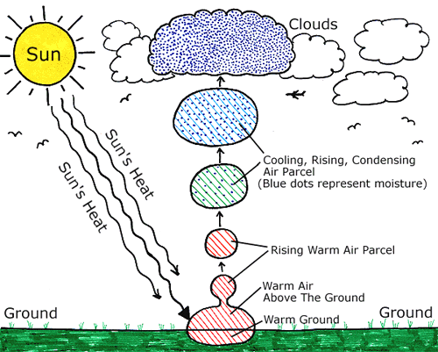

11. What causes air to rise?
- A portion of air may be lower in density than the air surrounding it due to higher temperatures, or more humidity - most common!!!
- Pushed up over a mountain
- Invasion of cooler air masses push warmer air masses aloft – t-storms form

12. In order for a cloud to form, condensation nuclei must be present in the atmosphere
- Provide a solid surface for a cloud to form on
- Salt from oceans, dust, smoke particles, pollen, pollutants
- If the air is too clean – clouds will not form

13. The height at which clouds will form is based on the dew point temperature of the rising air parcel.
- When air has a high dew point, it is more humid, clouds will form lower – bring rain

14. Determining Cloud Base Height……
- Need to know the Dry-bulb temperature AND the Dew point
- Use the graph

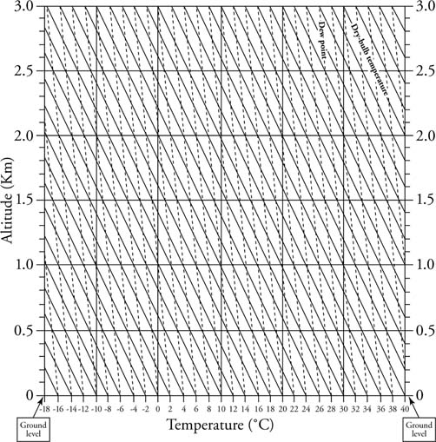

- Precipitation
15. Precipitation is water in the form of rain, snow, sleet, or hail that falls from the sky.
- Measured with a rain gauge and reported as depth in inches (or cm)

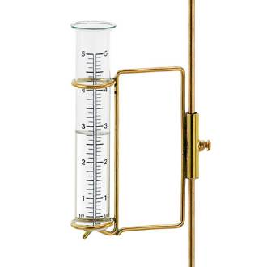

16. Most precipitation starts as snow and then melts as it falls through warmer sections of the atmosphere
- Rain – water droplets at least 0.5 millimeters in diameter
- Sleet – forms when rain passes through freezing air
- Freezing Rain – rain that freezes on contact with a cold surface
- Hail – round ice pellets that form in storm clouds due to up drafting
- Snow – ice crystals that form in cold clouds

- Phase Change
17. Water exists in all 3 phases (states of matter) within the atmosphere:
    - Solid – ice, snow crystals
    - Liquid – water (cloud droplets)
    - Gas – vapor

18. When water changes from one state to another, energy will either be absorbed or released.
- We call that energy latent heat, a form of potential energy
- Does not cause a temperature change!
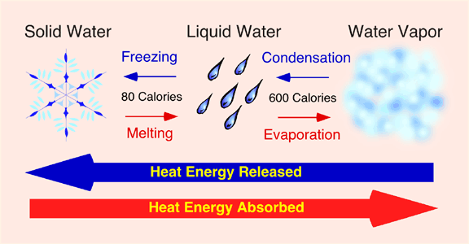

19. Heat and temperature are often confused……
Heat
-is a form of energy that is the result of the vibrational motion caused by the kinetic energy of atoms and molecules
-is measured in calories or joules
Temperature
-is a measure of the average kinetic energy of the atoms and molecules of a substance
-measure in degrees Fahrenheit or Celsius

20. 6 processes associated with phase change:
- Melting:
  - Solid to a liquid
  - Absorbs (gains) 334 joules/gram of latent heat
  - Energy needed to melt 1 g of water is known as the latent heat of fusion
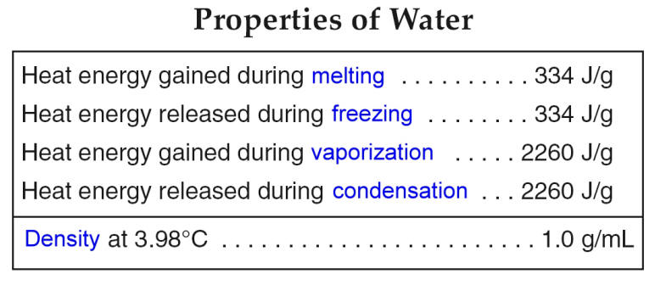
- Freezing:
  - Liquid to a solid
  - Releases 334 J/g

- Evaporation:
  - Liquid to a gas
  - Absorbs 2260 J/g
  - Energy needed to evaporate 1g of water is known as the latent heat of vaporization

- Condensation:
  - Gas to a liquid
  - Releases 2260 J/g

- Sublimation:
  - Solid to a gas
  - Absorbs 2594 J/g
  - Energy needed to sublimate 1g of water is known as the latent heat of sublimation

- Deposition:
  - Gas to a solid
  - Releases 2594 J/g
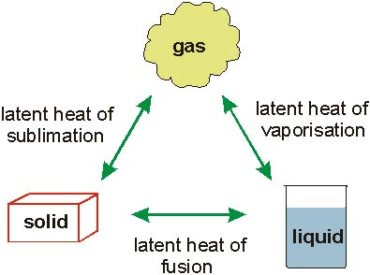

21. Several factors will affect the rate of evaporation of water:
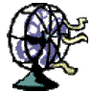
  - When water is uncovered or exposed
  - When water is heated
  - When water is exposed to wind
  - When water is spread out over a large area

22. When a substance changes phase, (solid-liquid-gas), it will absorb energy BUT will not increase in temperature until it has completely changed phase.
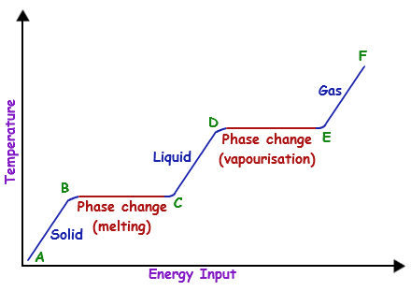

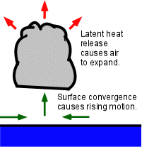
23. Severe storms are supported by latent heat energy released when condensation and deposition occur in the atmosphere.

Meteorology II
Part 4 – Weather Systems

A. Synoptic Weather Maps
1. Synoptic weather maps show a variety of atmospheric field qualities over a large geographical area.
- Temperature – isotherms (usually colored)
- Pressure – isobars (high and low pressure systems)
- Wind Patterns (speed and direction)
- Precipitation - Rain, snow
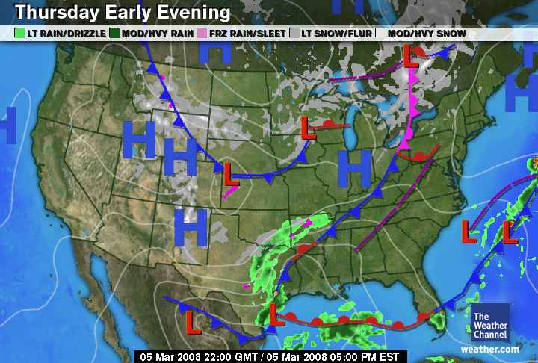

2. Because most weather systems move west to east across the United States, synoptic weather maps provide information that can be used to make weather predictions.

- Air Masses
3. Large bodies of air with uniform temperature, pressure, and humidity are called air masses.
- A huge section of the lower troposphere that has the same kind of weather throughout

4. Air masses originate in parts of the world where winds are light.
- The temperature of an air mass depends on whether it forms in the polar or tropical regions
- The humidity of an air mass depends on whether it forms over the land or the sea

5. Air masses are named for their source regions (places of origin)
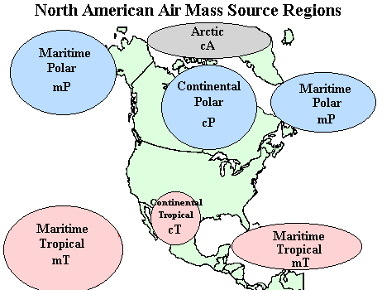
- Continental – land
- Maritime – ocean
- Tropical – warm areas
- Polar – cold areas

6. There are 5 types of air masses:
- Maritime Tropical (mT)
-comes from the tropical seas
-warm and humid
-Pacific, Atlantic, Gulf of Mexico

- Continental Tropical (cT)
-comes from the tropical land areas
-hot and dry air
-desert areas of southwestern US

- Maritime Polar (mP)
-comes from the cold ocean waters
-cold and humid

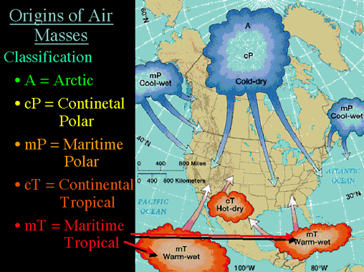
- Continental Polar (cP)
-comes from land areas in high latitudes
-cold and dry
-Canada and north

- Continental Artic (cA)
- from the ice covered Arctic region
- very cold and dry

- Fronts
7. The movement of air masses brings changes in weather.

8. The leading edge of an air mass is called a front
  - Boundary between 2 air masses
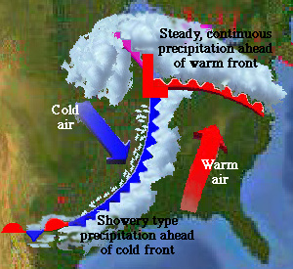

9. There are 4 kinds of fronts;
- Cold Fronts – cold air is advancing and displacing warmer air
- Warm Front – warm air is advancing and displacing colder air
- Stationary Front – when neither air mass is displaced and the front is not moving
- Occluded Front – When a cold front overtakes a warm front

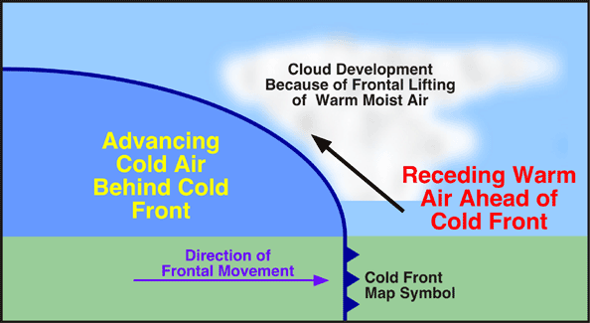
Cold Front

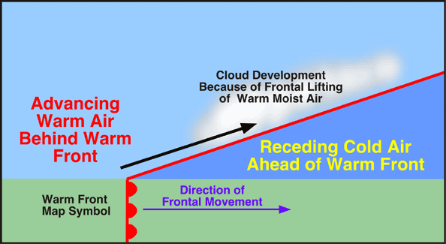

Warm Front

Occluded Front
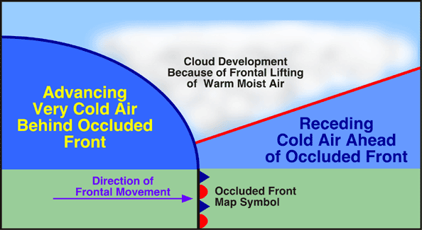
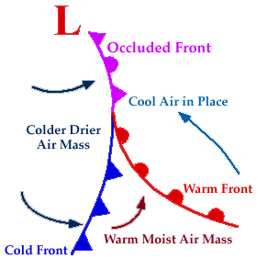

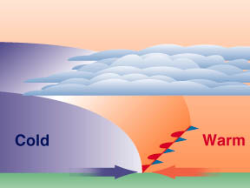

10. Each type of front brings a different type of weather:
- Cold Front –
  - Passes through quickly
  - Heavy rain and thunderstorms ahead of the front
  - After the front passes, it is cool and clear
- Warm Front –
  - Passage may take several days
  - Clouds form gradually
  - Warming and a drop in pressure follows the passage of the front
- Occluded Front –
  - Commonly associated with large areas of rainy, unsettled weather
- Stationary Front –
  - Weather will be steady until the front moves

- Pressure Systems
11. Large air masses that cover a large geographical area will develop into areas of either High Pressure (H) or Low Pressure (L)
- High Pressure Systems – (anticyclone)
- Low Pressure Systems – (cyclone)

12. High Pressure Systems:
- Anticyclone
- Zones of divergence where sinking air at the center causes winds to blow outward
- COOL and DRY
- Clear skies, stable conditions
- Spin CLOCKWISE due to Coriolis Effect

Draw:

13. Low Pressure Systems:
- Mid-latitude Cyclone
- Zones of convergence where winds blowing inward causes air to rise
- Rising air draws in different types of air masses and their associated fronts
- WARM and WET
- Changeable weather, cloudy skies, precipitation
Draw:

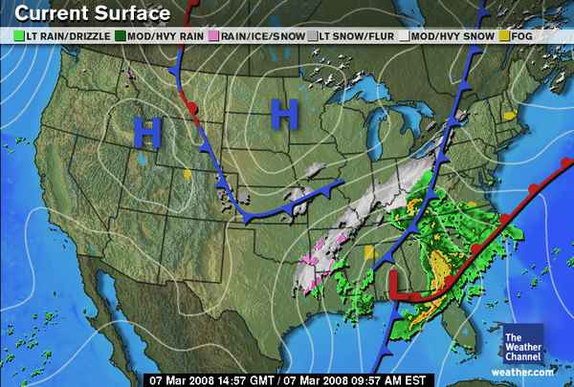

Part 5 – Storms

1. Each year, violent storms cause ________________________________________________.
- weather events cause the greatest loss of life
- droughts are sometimes called the “silent killers”

2. The destructive power of violent storms is a consequence of their energy.

- _____________________________________________________________

- Watches and Warning

3. When there is an approach of a severe thunderstorm, tornado, hurricane or winter storm, the National Weather Service issues a Watch or a Warning.

4. A ___________ covers an area 50 – 100 miles, and is given __________________________
_____________________________________________________________.

5. A ______________ is issued for an area when ever the ______________________________
_____________________________________________________________________________
____________________________________________________________________________.

-a warning gives the time and location that the storm will hit. (also amount of snow)
Ex. Hurricane Warning
Tropical Storm Warning
Winter Storm Warning
Severe Thunderstorm Warning

- Thunderstorms
6. Most thunderstorms occur __________________________________________
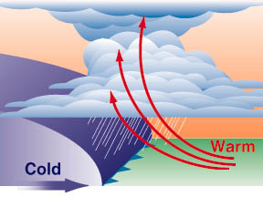

7. An advancing __________________________________________
________________________________________________________________________________________________________________
a. Lightning, hail and tornadoes cause the most destruction

8. To avoid hazards with thunderstorms you should seek shelter in a vehicle or building.


- Tornadoes

9. Tornadoes are more frequent in the US than any where else.

a. ________________________________________________________

b. ________________________________________________________

10. They are a ________________________________________________________________
a. the funnel is a mix of cloud and dust

11. Are formed when warm moist air from the Gulf of Mexico meets cool dry air from the Rockies.
a. the air is moist under the dry air on top
b. the wind speed is greater in the dry air above

12. Winds are from 72 mph (F0) to 250 mph (F5)

a. _____________________________________________________________________

b. _____________________________________________________________________

c. _____________________________________________________________________
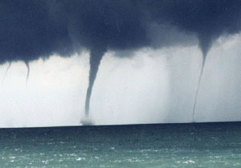
13. Tornadoes over water are called waterspouts.

D. Hurricanes
14. Hurricane:
-______________________________________________

____________________________________________________

____________________________________________________________________________.

15. Aspects of Hurricanes;
- ________________________________________________________________________
- ________________________________________________________________________
- ________________________________________________________________________
- They are not associated with ‘fronts’…________________________________________
__________________________________________________________________________
- _________________________________ surrounded by intense rotating winds and rain in the ‘eye wall’, and a less intense ‘outer bands’
- Loses strength slowly over cool water and quickly over land
- Causes property damage and loss of life due to __________________________________
__________________________________________________________________________

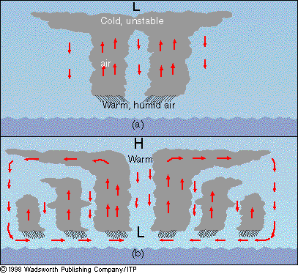

16. Stages of Development

_______________ _______________ _________________ ________________
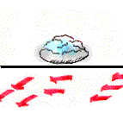
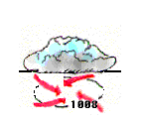
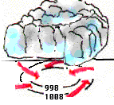
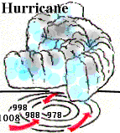

17. Storm Surge:
-forms when the hurricane ____________________________________________________.
-causes the ____________damage with a hurricane
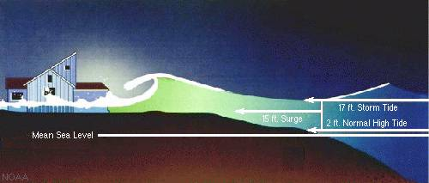
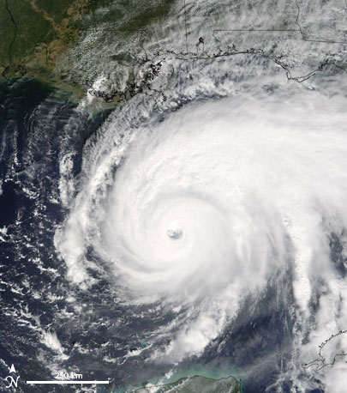


E. Winter Storms
18. Come from strong _______________________________________________.

19. In order to form there must be:
a. ____________________________________________________________
b. ____________________________________________________________

20. A Blizzard is a _____________________________________________________________.


21. A temperature difference of a few degrees can be the difference between
*heavy snow
*mixed rain and snow
*freezing rain
*rain
- This slight change in temperature can make it difficult to predict the exact kind and amount in a winter storm.

