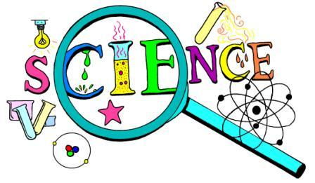
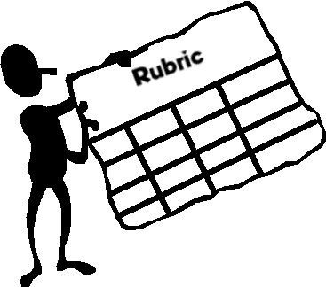
Science Lab Grading Rubric
Name:______________________________________________

 | Excellent  (full points) | Acceptable  (-3 to -5 points) | Needs work  (1/2 points) | Missing  (0 points)
Lab Investigation (50)

Personal Lab Skills (15)  -Contributes equally and constructively to the lab  -Lab and report turned in a professional looking manner  -Lab submitted on time | Student contributed equally and constructively to the lab environment.  Lab and report were submitted in a clean, clear and neat manner.  Lab was submitted by the due date. | Student participated but not constructively.  Lab and report were submitted mostly neat and presentable.  Lab was submitted one day late. | Student participated occasionally, but not equally or constructively.  Lab and report were submitted in a sloppy manner.  Lab was submitted within 2 days of the due date. | Student did not participate in the lab.  Lab was submitted ripped, torn, scribbled on and otherwise unsightly.  Lab was not submitted by its due date.
Manipulation Skills (10)  -Follows written and verbal directions  -Uses equipment in a safe and proper manner / cleans area  CCSS.ELA-Literacy.RST.9-10.3 Follow precisely a complex multistep procedure when carrying out experiments, taking measurements, or performing technical tasks, attending to special cases or exceptions defined in the text. | Student followed all written and verbal instructions carefully.  Student demonstrated respect and safety in the way the equipment was used and lab area was cleaned. | Student followed written and verbal directions with only one or two missteps.  Student used lab equipment properly and left the lab are mostly clean. | Student followed some of the directions and needed to be re-directed.  Student needed reminders on the proper use of lab equipment and need prompting to clean lab area. | Student did not follow written or verbal directions.  Student did not conduct themselves in a safe manner and did not show respect to lab equipment. Student did not clean lab area.
Data Collection / Results (15)  - Data tables, charts, and or graphs are completed clearly, accurately, and show units where appropriate  CCSS.ELA-Literacy.RST.9-10.7 Translate quantitative or technical information expressed in words in a text into visual form (e.g., a table or chart) and translate information expressed visually or mathematically (e.g., in an equation) into words. | Student’s data tables, charts, and graphs were completed neatly, accurately and with appropriate units. | Student’s data tables, charts, and graphs were completed but were missing one element (neatness, accuracy, or units). | Student’s data tables, charts, and graphs were completed but were missing two elements (neatness, accuracy, or units). | Student’s data tables, charts, and graphs were not completed OR were completed but were missing all elements (neatness, accuracy, or units).
Analysis and Conclusion Questions (10)  -Answers are written in complete sentences  -Answers are accurate and show evidence of referencing introduction, notes, and/or ESRT (when needed).  - CCSS.ELA-Literacy.RST.9-10.5 Analyze the structure of the relationships among concepts in a text, including relationships among key terms (e.g., force, friction, reaction force, energy). | Student’s answers are written in complete sentences and demonstrate understanding of content and lab objective through their accurateness and an analysis of the relationships amongst content.  Student used notes, text, or ESRT as needed. | Student’s answers are mostly written in complete sentences and generally demonstrate understanding of content and lab objective through their accurateness with only one to two incorrect answers and an analysis of the relationships amongst content. .  Student used notes, text, or ESRT as needed. | Some of the student’s answers are written in complete sentences and generally demonstrate understanding of content and lab objective through their accurateness with three to four incorrect answers. An analysis of relationships amongst content is not addressed.  Student did not use notes, text, or ESRT as needed. | Student’s answers are not written in complete sentences and do not demonstrate accurate understandings. An analysis of relationships amongst content is not addressed.  Student did not use notes, text, or ESRT as needed.
Lab Summary / Write up (50)

Objective (5)  -Objective is included at the beginning and matches the objective of the lab | Students accurately record the lab objective. | N/A | Student records an incomplete lab objective. | Student does not record the lab objective at all.
Summary (45)  -Includes clear statements of what occurred in the lab  -States how the lab data supports or contradicts the lab objective  -Identify the one area of the lab most likely responsible for measurable experimental error.  CCSS.ELA-Literacy.RST.9-10.9 Compare and contrast findings presented in a text to those from other sources (including their own experiments), noting when the findings support or contradict previous explanations or accounts. | Student provides clear statements of what occurred in the lab using correct grammar and spelling.  Student clearly interprets data and observations from graphs, diagrams, and/or charts. Student discusses how the identified sources of error could affect the outcome of the lab. | Student provides clear statement of what occurred in the lab without using correct grammar and spelling.  Student includes observations from graphs, diagrams, and/or charts. Student identifies relevant sources of error but does not state how it affected the outcome of the lab. | Student includes statements that are not clear about what occurred in the lab and are not written with correct grammar and spelling.  Student is lacking accurate and clear interpretation of data and observations from graphs and/or diagrams. Student’s sources of error that are discussed are not relevant. | Student does not provide any statement about what occurred during the lab.  Student provides no interpretation of data and/or observations.  Student does not identify sources of error.
Total = 100

Bonus (Xtra Credit) (5-10)  -Connects lab objective and data to content covered in class | Connects the data to what student has been learning in class using scientific vocabulary and textual resources. Student includes information not presented in class to support data.  CCSS.ELA-Literacy.RST.9-10.8 Assess the extent to which the reasoning and evidence in a text  support the author’s claim or a recommendation for solving a scientific or technical problem.

