Name:___________________________________
Lab: Using Star Maps
Introduction
Suppose you sat outside on a clear night gazing up at the stars. Imagine that the sky is a dome touching the ground around you at the horizon. The stars are points of light on the dome’s curved surface. If you were to view the dome of the stars on a regular basis throughout the year, you would notice that the starts move. Like the sun’s motion, the stars’ apparent motion in the sky are caused by the daily rotation of Earth on its axis and the yearly revolution of Earth in its orbit around the sun.
Star maps can be used to investigate seasonal changes in the evening sky. To read a star map, hold it directly overhead and turn it until the direction labels are aligned with compass directions. The four star maps you will use in this activity are four views of the celestial sphere taken every 3 months (Spring, Summer, Autumn, Winter) at the same time of night in the Northern Hemisphere.

Objective: You will locate several stars and constellations on star maps. You will be able to analyze the apparent motions of the stars and constellations over the seasons using theses maps.
Vocabulary
Polaris –
Rotation -
Revolution -
Constellation –
Apparent Motion –

Materials:
Season star maps, tracing paper, pencil
Procedure / Questions:
Part A: Locating Stars
1. Locate Polaris on each of the star maps. Does the position of Polaris relative to the northern horizon change throughout the year? __(yes / no)
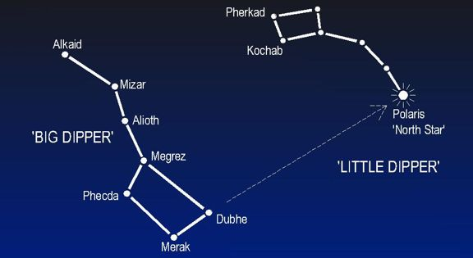
2. Locate the Big Dipper on the winter map. Note that the 2 stars in the Big Dipper are labeled “Pointers”. If a line connecting the “Pointers” continues to the right, to which star does it point?____________ (See example to the right)
So, then, how can the Big Dipper be used to find latitude in the Northern Hemisphere?
“Pointers”

3. Locate the on Winter map the 3 closely spaced stars in the middle of ORION. If a line is drawn through these stars and continued to the left, toward which constellation does it point? ____________________
4. Name the CONSTELLATION in which each of the following stars is located:
a) Polaris -
b) Antares -
c) Vega -
d) Spica -
e) Betelgeuse -
f) Sirius -
g) Rigel –

5. For each of the constellations listed on the table below, identify which season (by placing an “x” in the box) the constellation is overhead (middle of the map).
Constellation | Spring | Summer | Autumn | Winter
BOOTES
LYRA
ORION
PEGASUS

Part B: Apparent Motion
6. Using a sheet of tracing paper, trace the outline and compass directions from the Autumn map. Trace the outline of the Constellation GEMINI and write Autumn underneath it.
- Move the tracing paper to the Winter map and line up the compass directions. Trace the position of GEMINI during the winter season. Write Winter underneath it.
- Repeat as above for the Spring map. Note that GEMINI does not appear on the Summer map.
- Draw arrows between the season positions of GEMINI to show its direction of movement (Autumn → Winter → Spring).
- What general compass direction does GEMINI move across the sky over each of the seasons? ____________________________________________________________________________

7. In an open spot on the same sheet of tracing paper, trace the outline and compass directions from the Spring map. Mark the locations of the stars Vega, Deneb, and Altair. Connect the 3 stars to make a triangle and write Spring underneath it.
- Move the tracing paper to the Summer map and line up the compass directions. Trace the position the same stars and connect to make a triangle. Write Summer underneath it.
- Repeat as above for the Autumn map. Note that these stars do not appear on the Winter map.
- In what season does the Triangle rise above the horizon? __________
- What general compass direction does the triangle move across the sky over each of the seasons? _________________
- In which season does it set, or disappear below the horizon? ________________

8. In an open spot on the same sheet of tracing paper, trace the outline and compass directions from the Spring map. Mark and label Polaris and the constellation CASSIOPEIA. Write “A” underneath it.
- Move the tracing paper to the Summer map and mark and label Polaris and the constellation CASSIOPEIA. Write “B” underneath it.
- Draw an arrow from A → B. Has CASSIOPEIA moved clockwise or counterclockwise? _____________
- So the, what general direction can we infer that all constellations move over the seasons? ______________________

Map Analysis:
1. Explain why the Position of Polaris does not change relative to the northern Horizon during the year.

2. How can stars serve as “finding points” to help locate other stars and constellations?

3. Why do you think people on Earth cannot see all the constellations every season? Why are only some of them visible?

4. Describe the apparent motion of stars and constellations over the seasons.

